**Q1/Questions asked to get insights:**

1. What is the total number of orders by item, identifying the most popular products, we can focus on their promotion, ensure their availability, and explore opportunities for cross-selling or upselling.

select distinct stockcode ,sum(quantity) over(partition by stockcode ) as num_of_oreders_per_item

from retail

order by num_of_oreders_per_item desc;

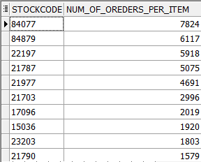

1. What is the total number of orders by customer. This information can be used to identify high-value customers and to develop targeted marketing campaigns to encourage them to continue shopping.

select distinct customer_id,

count(distinct invoice) over(partition by customer_id ) AS total_orders

from retail

order by total_orders desc;

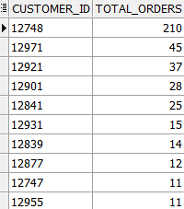

1. What is the total revenue generated by each customer. This query helps us understand the contribution of each customer to the total revenue. By identifying high-revenue customers, we can prioritize them for personalized offers and retention strategies.

select distinct customer_id,

sum(quantity * price) over (partition by customer_id )AS total_revenue

from retail

order by total_revenue desc;

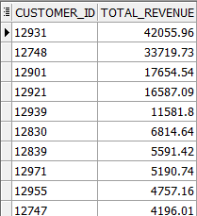

1. What is the monthly revenue trend over time? By analyzing the revenue trend over time, we can identify seasonal patterns, detect growth, or decline periods, and plan marketing campaigns or inventory management accordingly.

select distinct extract(year from to_date(invoicedate, 'MM/DD/YYYY HH24:MI')) as yearr,

extract(month from to_date(invoicedate, 'MM/DD/YYYY HH24:MI')) as monthh,

sum(quantity * price) over (partition by extract(year from to_date(invoicedate, 'MM/DD/YYYY HH24:MI')), extract(month from to_date(invoicedate, 'MM/DD/YYYY HH24:MI'))) as monthly_revenue

from retail

order by monthly_revenue desc;

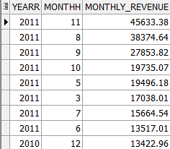

1. What is the customer churn rate. Description: Churn rate helps us understand the percentage of customers who have stopped purchasing. By tracking churn rate, we can identify at-risk customers and implement customer retention strategies to reduce churn.

with last_purchase_dates as (

select distinct customer_id,

last_value(to_date(invoicedate, 'MM/DD/YYYY HH24:MI')) over (partition by customer_id) as last_pur_date

from retail

),

churn_metrics as (

select count(distinct customer_id) as total_customers,

sum(

case

when last_pur_date < to_date('12/30/2011 11:59:59 PM', 'MM/DD/YYYY HH12:MI:SS AM') - interval '2' month then 1

else 0

end

) AS churned_customers

from last_purchase_dates

)

select total_customers,churned_customers,

round((churned_customers / total_customers)*100,2) as churn_rate

from churn_metrics;



1. The price of the stock is changing over time, the provided data is not sufficient to get insight, but I think it is very important to know why prices are changing and what is affecting it.

select stockcode,price,invoicedate

from retail

where stockcode='M';

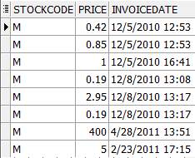

**Q2/segmenting customers**

with cu_info as (

select distinct customer_id,

round(to_date('12/09/2011 12:20:00 PM', 'MM/DD/YYYY HH12:MI:SS AM') - last_value(to_date(InvoiceDate, 'MM/DD/YYYY HH24:MI')) over (partition by customer_id)) as recency,

count(distinct invoice) over (partition by customer_id) as frequency,

sum(quantity * price) over (partition by customer_id) as monetary

from retail

),

scores as (

select distinct customer_id, recency,monetary,frequency,

ntile(5) over (order by recency) as rscore,

ntile(5) over (order by frequency) as fscore,

ntile(5) over (order by monetary) as mscore

from cu_info

),

fm as (

select distinct customer_id, round((fscore + mscore) / 2) as fm_score

from scores

),

finall as (

select distinct s.customer_id,s.rscore ,f.fm_score,

case

when s.rscore = 5 and f.fm_score in (4, 5) then 'Champions'

when s.rscore = 4 and f.fm_score = 5 then 'Champions'

when s.rscore = 5 and f.fm_score = 2 then 'Potential Loyalists'

when s.rscore = 4 and f.fm_score in (2, 3) then 'Loyal Customers'

when s.rscore = 3 and f.fm_score = 3 then 'Loyal Customers'

when s.rscore = 5 and f.fm_score = 3 then 'Loyal Customers'

when s.rscore = 4 and f.fm_score = 4 then 'Loyal Customers'

when s.rscore = 3 and f.fm_score in (5, 4) then 'Loyal Customers'

when s.rscore = 5 and f.fm_score = 1 then 'Recent Customers'

when s.rscore = 4 and f.fm_score = 1 then 'Promising'

when s.rscore = 3 and f.fm_score = 1 then 'Promising'

when s.rscore = 3 and f.fm_score = 2 then 'Customers Needing Attention'

when s.rscore = 2 and f.fm_score = 3 then 'Customers Needing Attention'

when s.rscore = 2 and f.fm_score = 2 then 'Customers Needing Attention'

when s.rscore = 2 and f.fm_score in (4, 5) then 'At Risk'

when s.rscore = 1 and f.fm_score = 3 then 'At Risk'

when s.rscore = 1 and f.fm_score in (4, 5) then 'Cant Lose Them'

when s.rscore = 1 and f.fm_score = 2 THEN 'Cant Lose Them'

when s.rscore = 1 and f.fm_score = 1 THEN 'Cant Lose Them'

else 'LOST'

end as segmentation

from fm f ,scores s

where f.customer_id = s.customer_id

)

select distinct fi.customer_id,c.frequency, c.recency,c.monetary,fi.rscore,fi.fm_score,segmentation

from finall fi ,cu_info c

where fi.customer_id = c.customer_id

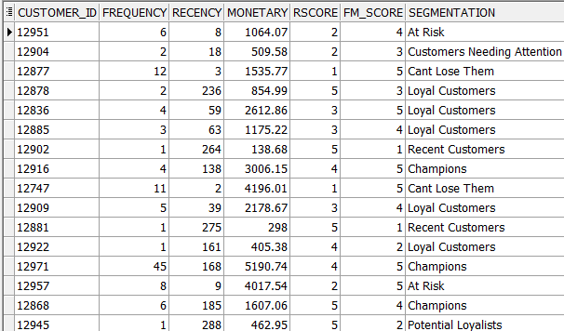

**Q3A/maximum number of consecutive days a customer made purchases.**

with cust_transactions as (

select cust_id, dt, lead(dt) over (partition by cust_id order by dt) as next_dt

from transactions

),

consecutive_days as (

select distinct Cust_id,count(*) over(partition by cust_id) as days

from cust_transactions

where next_dt - dt = '1'

)

select Cust_id, max(days) over(partition by cust_id) as maximum_consecutive_days

from consecutive_days;

**Q3B/How many days/transactions does it take a customer to reach a spent threshold of 250 L.E**

with ordered_transactions as (

select cust_id, dt, amt,

sum(amt) over (partition by cust_id order by dt) as total_amount,

row_number() over (partition by cust_id order by dt) as rn

from transactions

)

select avg(days_to_250) as average_days_to_thresh

from (

select cust_id, min(rn) over(partition by cust_id) as days_to_250

from ordered_transactions

where total_amount >= 250

)

